MINI PROJECT ON “TIC TAC TOE GAME”

Submitted in the partial fulfillment of the requirements for the award of degree of
BACHLOR IN COMPUTER APPLICATIONS
To
DEPARTMENT OF COMPUTER APPLICATIONS UTTARANCHAL INSTITUTE OF COMPUTING SCIENCES

UTTARANCHAL UNIVERSITY, DEHRADUN

Under the supervision of: Submitted By:
Mr. MANOJ ASWAL Anjali Rauthan
(Associate professor) 2536090030

BCA-1 I I SEM
UTTARANCHAL UNIVERSITY, (DEHRADUN)2025

ACKNOWLEDGEMENT

First and foremost, I will be eternally grateful to God, to whom I owe my life. I'd also like to thank my parents for allowing me to attend Uttaranchal University in Dehradun. I'd like to convey my heartfelt appreciation to our Project Mentors, Prof. Manoj Aswal for their invaluable assistance in preparing the project and compiling the project materials. I am grateful for their consistent blessings and for providing the necessary and related facilities for our computer project file. Most importantly. I'd also like to thank everyone who helped me finish my project, whether directly or indirectly.

Anjali Rauthan
BCA-2 SEM

DECLARATION

I hereby declare that this project work entitled “TIC TAC TOE GAME” submitted by Anjali Rauthan to Uttaranchal Institute of Computing sciences. It is an authentic record of my work carried out at
“UTTARANCHAL UNIVERSITY” under the guidance of Prof. Deepak Kumar.

Anjali Rauthan
BCA-2 SEM

3

CERTIFICATE OF ORIGINALITY


This is to certify that the project entitled “TIC TAC TOE GAME” by ANJALI RAUTHAN has been submitted in the partial fulfillment of the requirements for the award of the degree of BCA-2 from Uttaranchal University, Dehradun. The results embodied in this project have not been submitted to any other University or Institution for the record of any degree.

Under the guidance of:

Prof. MANOJ ASWAL

Associate professor (USCS)

Uttaranchal University, Dehradun

1. INTRODUCTION

The Tic Tac Toe Game is one of the most popular and simple strategy games played around the world. It is a two-player game that is usually played on a 3×3 grid. In this game, one player uses the symbol “X” and the other player uses the symbol “O”. The players take turns placing their symbols in the empty spaces of the grid. The main objective of the game is to create a straight line of three matching symbols either horizontally, vertically, or diagonally before the opponent does. If all the spaces in the grid are filled and no player has formed a straight line, the game ends in a draw.
The Tic Tac Toe game is widely used as a beginner-level project in programming and computer science. It helps students understand the basic concepts of programming such as conditional statements, loops, arrays, and user input handling. Developing this game allows programmers to apply logical thinking and problem-solving skills to control how the game operates, how players interact with the system, and how the program checks for a winning condition.
This project aims to design and implement a simple Tic Tac Toe game using programming concepts. The game allows two players to play alternately by entering their moves until one of the players wins or the game ends in a draw. The program checks the game board after every move to determine whether a player has successfully created a winning combination of three symbols in a row.
In addition to being entertaining, the Tic Tac Toe game also serves as a good example for learning the fundamentals of game development and algorithm design. It introduces students to the idea of structuring a program, handling user interaction, and implementing game rules in a logical manner. Although the game itself is simple, it forms the foundation for understanding more complex games and applications in the future.
Overall, the Tic Tac Toe project provides a practical learning experience for beginners in programming. It helps improve coding skills, logical reasoning, and understanding of how computer programs can simulate real-world games. Through this project, students gain valuable experience in designing and implementing a complete working program.

2. OBJECTIVES

The main objective of developing the Tic Tac Toe Game project is to understand and apply the basic concepts of programming through a simple and interactive game. This project helps students learn how logical thinking and programming techniques can be used to design and implement a real-world application. By creating this game, learners gain practical experience in writing structured programs and handling user interaction effectively.
One of the primary objectives of this project is to understand how a game can be developed using programming logic. The Tic Tac Toe game requires the use of different programming elements such as loops, conditional statements, arrays, and functions. Through this project, students learn how to organize these elements to control the flow of the program and ensure that the game runs smoothly.
Another objective is to develop problem-solving and logical thinking skills. The program must check whether a player has won the game after every move. This requires designing an algorithm that can evaluate all possible winning combinations such as rows, columns, and diagonals. By implementing this logic, students learn how to break down a problem into smaller steps and solve it effectively.
The project also aims to improve the understanding of user input and output operations. In the game, players must enter their moves through the keyboard, and the program must display the updated game board after each move. This helps students understand how programs interact with users and how information can be processed and displayed.
Another important objective is to provide a basic introduction to game development concepts. Although Tic Tac Toe is a simple game, it demonstrates how rules, player turns, and winning conditions are implemented in a program. This experience helps learners build a foundation for developing more advanced games and applications in the future.
Finally, the project aims to enhance programming confidence among beginners. By successfully developing and running the Tic Tac Toe game, students gain a better understanding of programming concepts and become more confident in writing and testing their own programs. Overall, the objective of this project is to combine learning with creativity and provide a practical approach to understanding computer programming.

.

3. Scope of the Project

The Tic Tac Toe Game project focuses on developing a simple two-player game that demonstrates the basic concepts of programming and logical problem solving. The scope of this project is limited to designing and implementing a basic game where two players can play alternately on a 3×3 grid using the symbols X and O. The program manages the game board, accepts player input, and determines the winner based on the rules of the game.
This project mainly covers the implementation of fundamental programming features such as loops, conditional statements, arrays, and functions. It provides an opportunity to understand how a program can control the flow of a game, display the current state of the board, and check for winning conditions. The program also ensures that the players take turns properly and that the game ends when a player wins or when all positions on the grid are filled.
The scope of the project also includes providing a simple and interactive interface where players can enter their moves and view the updated game board. It demonstrates how user input is processed and how the output is displayed in a clear and organized manner. This helps in understanding how programs interact with users and how data is handled within a program.
However, the project is limited to a basic version of the game and does not include advanced features such as artificial intelligence, graphical user interfaces, or online multiplayer functionality. The main aim is to focus on the core logic and structure of the game rather than complex design elements.
Overall, the scope of the Tic Tac Toe project is to provide a practical learning experience for beginners in programming. It helps in building a strong foundation in coding, logical thinking, and program design, which can be further expanded in the future to develop more advanced games and applications.

4 Software/tools used;

The development of the Tic Tac Toe Game project requires basic software tools that help in writing, editing, compiling, and executing the program. The tools used in this project are simple and beginner-friendly, making it easy to understand and implement the game.
- Programming Language (C / Python)
The game is developed using a programming language such as C or Python. These languages are widely used for beginners and help in implementing the game logic using conditions, loops, and functions.
- Code Editor / IDE
A code editor or Integrated Development Environment (IDE) is used to write and manage the program code. Some commonly used tools include Turbo C, Code::Blocks, Dev C++, or Visual Studio Code. These tools provide features like syntax highlighting, error detection, and easy code execution.
- Compiler / Interpreter
A compiler (for C language) or interpreter (for Python) is used to convert the written code into a format that the computer can understand and execute. For example, GCC compiler is used for C programs, while Python has its own built-in interpreter.
- Operating System
The project can be developed and executed on any operating system such as Windows, Linux, or macOS. The operating system provides the environment in which the software tools run.
- Command Prompt / Terminal
The Command Prompt (in Windows) or Terminal (in Linux/macOS) is used to compile and run the program, especially when not using an IDE.

4.1.1 EXISTING SYSTEM
The existing system of the Tic Tac Toe Game is primarily based on the traditional manual method of playing the game. In this method, the game is played using pen and paper where a 3×3 grid is drawn, and two players take turns marking “X” and “O” in the boxes. The players continue playing until one of them forms a straight line or the game ends in a draw.
While the manual system is simple and easy to understand, it has several limitations. It does not provide any automated checking of rules, so players must manually verify whether a winning condition has been achieved. This can sometimes lead to errors or disagreements between players. Additionally, the manual system does not store any game history or results, making it difficult to track performance over time.
Another limitation of the existing system is that it lacks interactivity and engagement. It does not provide any guidance, feedback, or validation for incorrect moves, such as placing a symbol in an already occupied position. Also, it cannot be played remotely or against a computer, which limits its usability.
Due to these drawbacks, there is a need for a computerized version of the Tic Tac Toe game. The proposed system overcomes these limitations by automating the game process, ensuring correct rule implementation, and providing a better user experience.

4.1.2 PROPOSED SYSTEM

The proposed system aims to develop a computerized version of the Tic Tac Toe Game that overcomes the limitations of the existing manual system. This system will automate the entire gameplay process, making it more efficient, accurate, and user-friendly. The game will be designed in such a way that two players can easily play by entering their moves through the system.
In the proposed system, the game board will be displayed on the screen, and players will take turns entering their choices. The program will automatically place the symbols “X” and “O” in the selected positions and update the board after each move. It will also check for valid inputs to ensure that players do not select an already occupied position.
One of the key features of the proposed system is the automatic detection of the winning condition. The program will check after every move whether a player has successfully formed a straight line either horizontally, vertically, or diagonally. If a player wins, the system will display the result immediately. If all positions are filled and no player wins, the system will declare the game as a draw.
The proposed system also improves user interaction by providing clear instructions and feedback during the game. It reduces the chances of errors, eliminates the need for manual checking, and ensures fair gameplay. Additionally, the system can be further enhanced in the future by adding features such as a single-player mode (playing against the computer), graphical user interface (GUI), or score tracking.
Overall, the proposed system provides a simple, efficient, and interactive way to play the Tic Tac Toe game while demonstrating the practical application of programming concepts.

PRELIMINARY INVESTIGATION

The preliminary investigation is the first and most important step in the development of the Tic Tac Toe Game project. In this phase, the basic idea of the project is studied to determine its feasibility, requirements, and overall objectives. It involves understanding the problem, analyzing the existing system, and identifying the need for a computerized solution.
During this stage, the traditional method of playing Tic Tac Toe (using pen and paper) is examined. It is observed that while the manual system is simple, it lacks automation, accuracy, and user convenience. There is no automatic validation of moves, no instant result checking, and no way to store or track game data. These limitations highlight the need for a digital version of the game.
The investigation also includes gathering the basic requirements for the proposed system. The system should allow two players to play alternately, accept user inputs, display the game board, and check for winning conditions after each move. It should also ensure that invalid moves are not allowed and that the game ends correctly with a win or draw result.
Feasibility analysis is another important part of this phase. The project is technically feasible as it requires only basic programming knowledge and simple tools such as a programming language (C or Python) and a compiler or interpreter. It is also economically feasible because no special hardware or expensive software is required. Additionally, the project is operationally feasible as it is easy to use and understand by users.
Overall, the preliminary investigation confirms that the development of the Tic Tac Toe Game is practical and beneficial. It provides a clear understanding of the problem and lays the foundation for designing and implementing an effective solution.

5.1 FEASIBILITY STUDY

The feasibility study is an important step in the development of the Tic Tac Toe Game project. It helps to determine whether the proposed system is practical, achievable, and worth implementing. This phase evaluates different aspects such as technical, economic, and operational feasibility to ensure that the project can be successfully completed.

- Technical Feasibility
The Tic Tac Toe game is technically feasible because it requires only basic programming knowledge and simple tools. The game can be developed using programming languages like C or Python, which are easy to learn and widely available. It does not require any advanced hardware or complex software. The system can run on a standard computer, making it easy to implement and execute.

2. Economic Feasibility
The project is economically feasible as it involves minimal cost. No expensive software, hardware, or resources are required for development. Most of the tools used, such as programming languages and code editors, are freely available. Therefore, the project can be completed within a low budget, making it cost-effective.

3. Operational Feasibility
The proposed system is user-friendly and easy to operate. Players can easily understand the rules and interact with the system without any special training. The game provides clear instructions and feedback, ensuring smooth gameplay. This makes the system operationally feasible for users of all levels.

4. Time Feasibility
The project can be completed within a short period of time since it is simple and does not involve complex features. With proper planning and basic programming skills, the Tic Tac Toe game can be developed and tested efficiently within the given time frame.
Overall, the feasibility study shows that the Tic Tac Toe Game project is practical, low-cost, easy to implement, and suitable for learning purposes. It confirms that the project can be successfully developed and used effectively.

6. PROJECT PLANNING

Project planning is an essential phase in the development of the Tic Tac Toe Game. It involves organizing the tasks, resources, and time required to successfully complete the project. Proper planning ensures that the development process is smooth, systematic, and completed within the given time frame.
In this project, the first step is to clearly define the objectives and requirements of the game. The system should allow two players to play alternately, display a 3×3 grid, accept user inputs, and check for winning or draw conditions. Once the requirements are defined, the design of the program is planned, including how the game board will be represented and how the logic will be implemented.
The project is then divided into smaller tasks such as designing the game structure, writing the code, testing the program, and debugging errors. Each task is scheduled in a proper sequence to ensure efficient development. For example, the game board design is completed first, followed by implementing player turns, then adding the logic to check for winners, and finally testing the complete system.
Time management is also an important part of project planning. A simple schedule is created to allocate time for each phase of development. Since the Tic Tac Toe game is a small project, it can be completed within a short duration, but proper planning helps avoid delays and ensures timely completion.
Resource planning is minimal for this project, as it only requires a computer, a programming language (such as C or Python), and a code editor or compiler. No additional hardware or expensive tools are needed.
Finally, testing and evaluation are included in the planning phase to ensure that the game works correctly. The program is tested for different scenarios such as valid moves, invalid inputs, winning conditions, and draw situations.
Overall, project planning provides a clear roadmap for developing the Tic Tac Toe Game, ensuring that all tasks are completed efficiently and the final program works as expected.

7.PROJECT SCHEDULING
Project scheduling is the process of organizing and allocating time to different activities involved in the development of the Tic Tac Toe Game. It helps in completing the project in a systematic and timely manner by defining when each task should start and finish.
In this project, the development work is divided into several phases such as requirement analysis, design, coding, testing, and implementation. Each phase is assigned a specific time period to ensure smooth progress and avoid delays. Since the Tic Tac Toe game is a simple project, the overall development can be completed within a short duration.
A basic schedule for the project is as follows:
- Requirement Analysis (1–2 days):
Understanding the game rules, identifying system requirements, and analyzing the existing system.
- System Design (2–3 days):
Planning the structure of the program, designing the game board, and deciding the logic for player moves and win conditions.
- Coding / Development (3–5 days):
Writing the program using a suitable programming language such as C or Python, and implementing all required features.
- Testing and Debugging (2–3 days):
Checking the program for errors, fixing bugs, and ensuring that all game conditions work correctly.
- Implementation and Documentation (1–2 days):
Final execution of the program and preparing project documentation such as report, diagrams, and explanations.
Project scheduling helps in proper time management and ensures that each phase is completed efficiently. It also makes it easier to track progress and identify any delays during development.
Overall, a well-planned schedule ensures that the Tic Tac Toe Game project is completed successfully within the given time frame while maintaining quality and accuracy.

7.1 GANTT CHART
A Gantt Chart is a visual representation of the project schedule. It shows the timeline of different tasks involved in the development of the Tic Tac Toe Game and helps in tracking progress effectively.

Task | Day 1 | Day 2 | Day 3 | Day 4 | Day 5 | Day 6 | Day 7 | Day 8 | Day 9 | Day 10
Requirement Analysis | █ | █
System Design |  |  | █ | █
Coding / Development |  |  |  |  | █ | █ | █
Testing & Debugging |  |  |  |  |  |  | █ | █
Implementation & Report |  |  |  |  |  |  |  |  | █ | █

Explanation:
- Each █ represents the days allocated to a specific task.
- The chart shows how tasks are distributed over 10 days.
- Some tasks may slightly overlap depending on progress.

7.2 PERT CHART

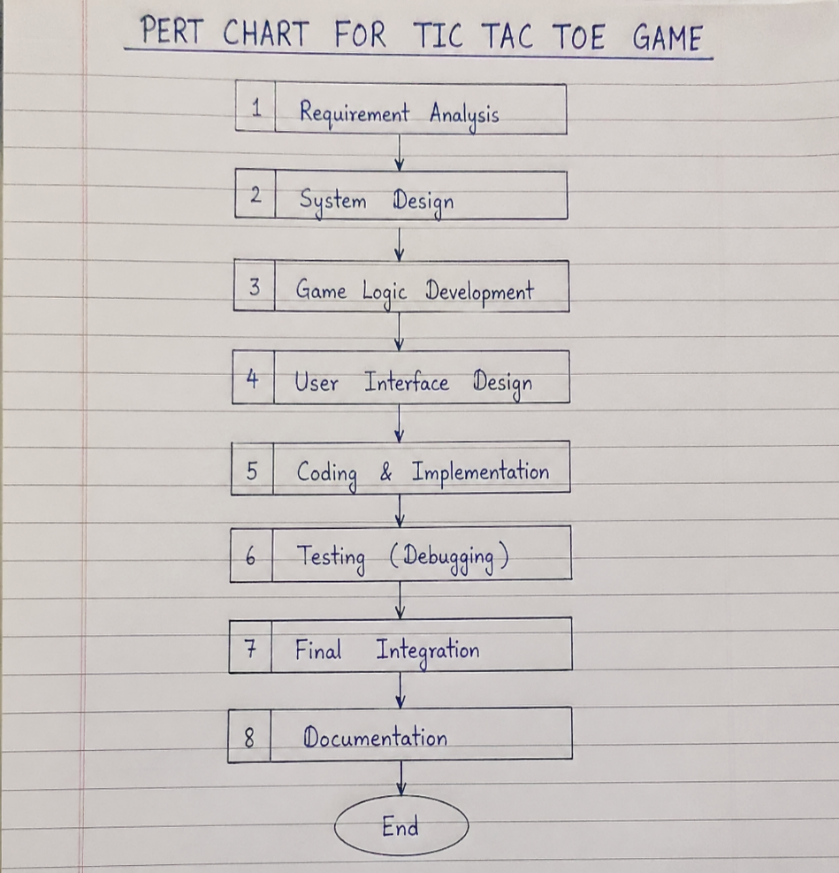

A PERT (Program Evaluation and Review Technique) Chart is a project management tool used to represent the sequence of activities involved in a project. It shows the order in which tasks must be completed and helps in identifying the dependencies between different stages of the Tic Tac Toe Game development.

In this project, the main activities are connected in a logical sequence, where one task depends on the completion of the previous task. The PERT chart helps in better planning, scheduling, and controlling the project.

Steps in PERT Chart for Tic Tac Toe Game:
- A – Requirement Analysis
Understanding the game rules and system requirements.
- B – System Design (depends on A)
Designing the structure of the game and logic.
- C – Coding / Development (depends on B)
Writing the program and implementing features.
- D – Testing & Debugging (depends on C)
Checking errors and fixing bugs.
- E – Implementation & Documentation (depends on D)
Final execution and preparation of the report.

PERT Chart Representation:
A → B → C → D → E
Explanation:
- Each activity must be completed before moving to the next.
- The flow shows the dependency of tasks from start to end.
- It helps in identifying the critical path, which is the longest sequence of tasks that determines the minimum time required to complete the project.
The PERT Chart is useful for organizing tasks, improving time management, and ensuring that the Tic Tac Toe Game project is completed in a structured and efficient manner.

DFD (Data Flow Diagram)
A Data Flow Diagram (DFD) is a graphical representation of how data moves through a system. It shows the flow of information between different processes, data stores, and external entities. In the Tic Tac Toe Game project, the DFD helps in understanding how user inputs are processed and how the game produces outputs.
Components of DFD
A DFD mainly consists of the following elements:
- External Entity: Represents the user (players).
- Process: Represents the operations performed (game logic).
- Data Flow: Movement of data between components.
- Data Store: Storage of game data (game board).

Level 0 DFD (Context Diagram)
In the Level 0 DFD, the entire system is represented as a single process.
Description:
- The Player provides input (position choice).
- The Tic Tac Toe System processes the input.
- The system outputs the updated game board and result (win/draw).
Representation:
[Player] → (Tic Tac Toe System) → [Game Output]

Level 1 DFD
This level breaks down the main system into smaller processes.
Processes involved:
- Input Handling: Takes player input.
- Validate Move: Checks if the move is valid.
- Update Board: Places X or O in the grid.
- Check Winner: Verifies winning condition.
- Display Output: Shows updated board and result.
Representation:
[Player] → (Input Handling) → (Validate Move) → (Update Board) → (Check Winner) → (Display Output)

Explanation
- The player interacts with the system by entering moves.
- The system validates and processes the input step-by-step.
- The game board acts as a data store where moves are recorded.
- The output is displayed after every move, showing the current status of the game.

Overall, the DFD provides a clear understanding of how data flows within the Tic Tac Toe Game system and helps in designing and developing the program effectively.

8.2SEQUENCE DIAGRAM

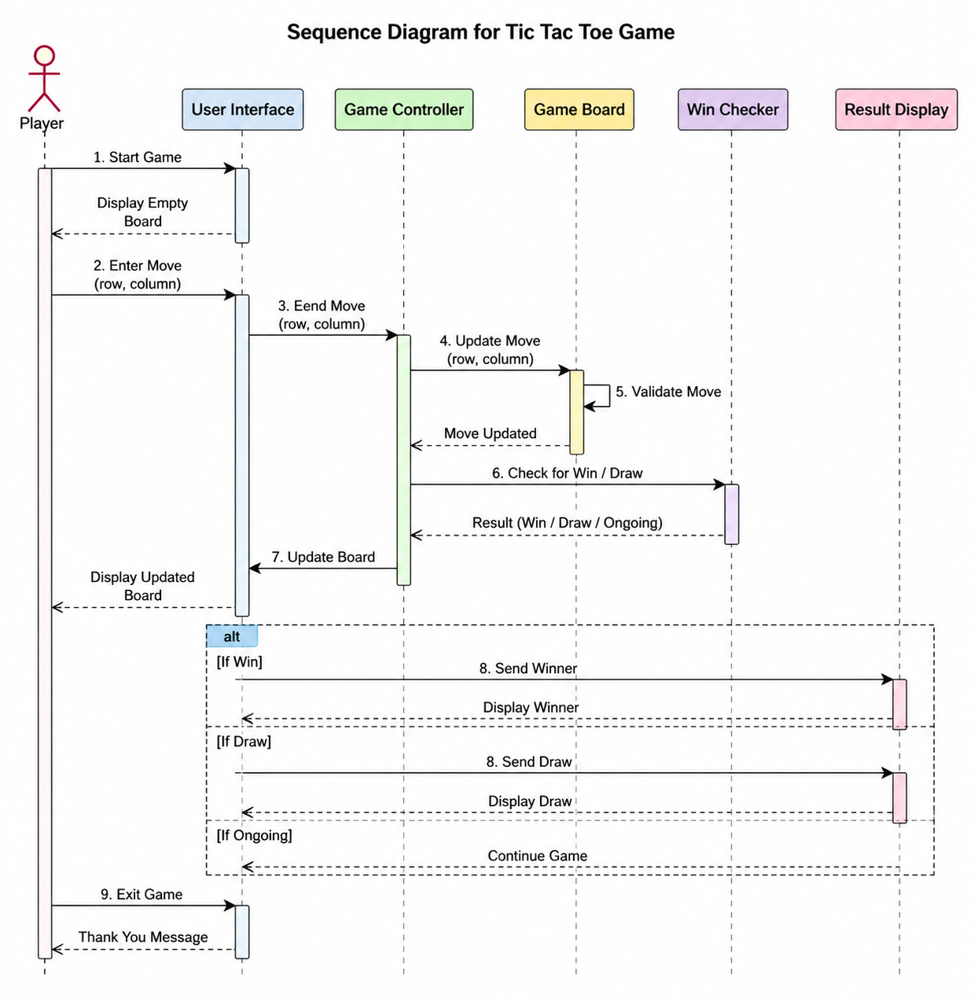

8.2 Sequence Diagram
A Sequence Diagram is a type of diagram that shows how different parts of a system interact with each other in a particular sequence of time. It represents the flow of messages between objects or components in the Tic Tac Toe Game. This diagram helps in understanding how the system processes user actions step-by-step.

Components of Sequence Diagram
- Actors: Player 1 and Player 2
- Objects: Game System, Game Board
- Messages: Input moves, validation, update, and result display

Sequence of Operations
- Player 1 enters a move (position).
- The Game System receives the input.
- The system validates the move (checks if the position is empty).
- If valid, the system updates the game board with “X”.
- The system checks for a winner.
- The updated board is displayed.
- Player 2 enters the next move.
- The same process is repeated using “O”.
- The sequence continues until a player wins or the game ends in a draw.

Sequence Diagram Representation
Player 1 → Game System : Enter Move
Game System → Game Board : Validate Move
Game Board → Game System : Valid / Invalid
Game System → Game Board : Update Board (X)
Game System → Game System : Check Winner
Game System → Player : Display Board

Player 2 → Game System : Enter Move
Game System → Game Board : Validate Move
Game Board → Game System : Valid / Invalid
Game System → Game Board : Update Board (O)
Game System → Game System : Check Winner
Game System → Player : Display Board

Explanation
The sequence diagram clearly shows the interaction between players and the system in a step-by-step manner. Each action follows a specific order, ensuring that the game runs correctly. It helps in understanding the flow of control and communication within the Tic Tac Toe Game.
Overall, the sequence diagram provides a clear visualization of how the system responds to user inputs and manages the game process efficiently.

8.4 CLASS DIAGRAM

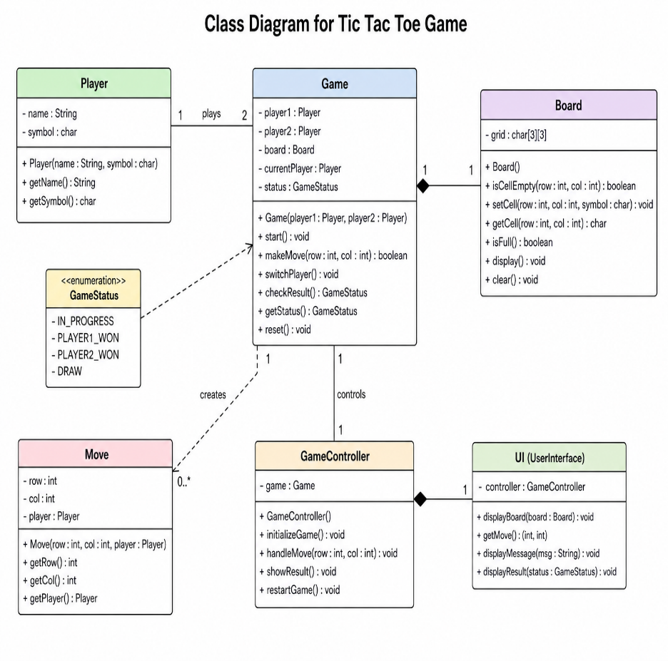
A Class Diagram is a type of UML (Unified Modeling Language) diagram that represents the structure of a system by showing its classes, attributes, methods, and relationships. In the Tic Tac Toe Game, the class diagram helps in understanding how different parts of the program are organized and how they interact with each other.

Main Classes in Tic Tac Toe Game
1. Game Class
- Attributes:
  - board[3][3] (stores game grid)
  - currentPlayer
- Methods:
  - startGame()
  - switchPlayer()
  - checkWinner()
  - isDraw()

2. Player Class
- Attributes:
  - name
  - symbol (X or O)
- Methods:
  - makeMove()

3. Board Class
- Attributes:
  - grid[3][3]
- Methods:
  - displayBoard()
  - updateBoard(position, symbol)
  - isCellEmpty(position)

Relationships
- The Game class controls the overall flow and uses both Player and Board classes.
- The Player interacts with the Game by making moves.
- The Board class manages the game state and updates the grid.

Class Diagram Representation
+------------------+
| Game |
+------------------+
| board[3][3] |
| currentPlayer |
+------------------+
| startGame() |
| switchPlayer() |
| checkWinner() |
| isDraw() |
+------------------+
|
| uses
v
+------------------+ +------------------+
| Player | | Board |
+------------------+ +------------------+
| name | | grid[3][3] |
| symbol | +------------------+
+------------------+ | displayBoard() |
| makeMove() | | updateBoard() |
+------------------+ | isCellEmpty() |
+------------------+

Explanation
The class diagram shows how the system is divided into different classes, each with specific responsibilities. The Game class manages the overall logic, the Player class handles user actions, and the Board class maintains the game state. This structure makes the program organized, modular, and easy to understand.
Overall, the class diagram provides a clear blueprint for implementing the Tic Tac Toe Game in an object-oriented manner.

8.5 ACTIVITY DIAGRAM

8.4 Activity Diagram
An Activity Diagram is a UML diagram that represents the flow of activities or actions in a system. It shows the step-by-step workflow of the Tic Tac Toe Game, from the start of the game to the final result. It helps in understanding how the system operates and how decisions are made during the game.

Main Activities in Tic Tac Toe Game
- Start Game
- Initialize game board (empty 3×3 grid)
- Display game board
- Player enters move
- Validate move
- Update board (place X or O)
- Check for winner
- Check for draw
- Switch player
- Repeat until game ends
- Display result (Win/Draw)
- End Game

Activity Diagram Representation
(Start)
↓
Initialize Board
↓
Display Board
↓
Player Enters Move
↓
[Is Move Valid?] ── No ──> Ask for Input Again
│
Yes
↓
Update Board (X/O)
↓
[Winner?] ── Yes ──> Display Winner → (End)
│
No
↓
[Draw?] ── Yes ──> Display Draw → (End)
│
No
↓
Switch Player
↓
Repeat Process

Explanation
- The diagram starts with initializing the game board.
- Players enter their moves one by one.
- The system checks whether the move is valid before updating the board.
- After each move, the system checks if there is a winner or if the game is a draw.
- If neither condition is met, the turn switches to the next player and the process repeats.
- The game ends when a player wins or when all positions are filled.

Overall, the activity diagram provides a clear visualization of the workflow of the Tic Tac Toe Game, helping in better understanding and implementation of the system.

Company 1 9. Company Profile
Company Name: XYZ Software Solutions Pvt. Ltd.
Introduction:
XYZ Software Solutions Pvt. Ltd. is a leading software development company that specializes in creating innovative and user-friendly applications. The company focuses on delivering high-quality software solutions for educational, business, and entertainment purposes. It is known for its strong technical expertise and commitment to client satisfaction.
Vision:
To become a globally recognized software company by providing reliable and efficient digital solutions.
Mission:
To develop high-quality software products that meet user requirements and enhance productivity through innovation and technology.
Services Offered:
- Software Development
- Web Application Development
- Mobile Application Development
- Game Development
- IT Consulting Services
Technologies Used:
The company uses modern technologies such as C, C++, Java, Python, HTML, CSS, and JavaScript to develop efficient and scalable applications.
Team Structure:
The company consists of skilled professionals including software developers, designers, testers, and project managers who work together to deliver successful projects.
Conclusion:
XYZ Software Solutions Pvt. Ltd. provides a strong foundation for developing projects like the Tic Tac Toe Game by offering the necessary tools, guidance, and technical support.

Company Name: ABC Technologies Pvt. Ltd.
Introduction:
ABC Technologies Pvt. Ltd. is a well-established IT company that provides a wide range of software and technology-based solutions. The company focuses on delivering innovative and efficient applications for various sectors such as education, business, and entertainment. It is known for its quality services, customer satisfaction, and modern development practices.
Vision:
To be a trusted leader in the IT industry by delivering advanced and reliable technology solutions.
Mission:
To provide cost-effective, high-quality software solutions that meet the needs of clients and help them achieve their goals.
Services Offered:
- Custom Software Development
- Web Development
- Mobile App Development
- Game Development
- Cloud-Based Solutions
Technologies Used:
ABC Technologies uses advanced programming languages and tools such as Java, Python, C++, PHP, HTML, CSS, and JavaScript to build efficient applications.
Team Structure:
The company has a dedicated team of developers, designers, testers, and project managers who work collaboratively to ensure successful project delivery.
Conclusion:
ABC Technologies Pvt. Ltd. offers a professional environment and technical expertise that supports the development of projects like the Tic Tac Toe Game, helping learners gain practical knowledge and experience in software development.

CODE
#include <iostream>
using namespace std;

char board[3][3] = {
{'1','2','3'},
{'4','5','6'},
{'7','8','9'}
};

char player = 'X';

// Function to display board
void displayBoard() {
cout << "\n";
for(int i = 0; i < 3; i++) {
cout << " ";
for(int j = 0; j < 3; j++) {
cout << board[i][j];
if(j < 2) cout << " | ";
}
if(i < 2) cout << "\n-----------\n";
}
cout << "\n";
}

// Function to place mark
void makeMove() {
int choice;
cout << "\nPlayer " << player << ", enter position (1-9): ";
cin >> choice;

int row = (choice - 1) / 3;
int col = (choice - 1) % 3;

if(board[row][col] != 'X' && board[row][col] != 'O') {
board[row][col] = player;
player = (player == 'X') ? 'O' : 'X';
} else {
cout << "Invalid move! Try again.\n";
makeMove();
}
}

// Function to check winner
bool checkWin() {
// Rows & Columns
for(int i = 0; i < 3; i++) {
if(board[i][0] == board[i][1] && board[i][1] == board[i][2])
return true;
if(board[0][i] == board[1][i] && board[1][i] == board[2][i])
return true;
}

// Diagonals
if(board[0][0] == board[1][1] && board[1][1] == board[2][2])
return true;
if(board[0][2] == board[1][1] && board[1][1] == board[2][0])
return true;

return false;
}

// Main function
int main() {
int moves = 0;
bool win = false;

cout << "TIC TAC TOE GAME\n";

while(moves < 9 && !win) {
displayBoard();
makeMove();
moves++;
win = checkWin();
}

displayBoard();

if(win) {
cout << "\nPlayer " << (player == 'X' ? 'O' : 'X') << " wins!\n";
} else {
cout << "\nIt's a draw!\n";
}

return 0;
}

9.METHODOLOGY

The methodology of the Tic Tac Toe Game project describes the step-by-step approach used to design, develop, and implement the system. It provides a clear understanding of how the project is carried out from the initial stage to the final execution.

The development of this project follows a structured approach, starting with understanding the problem and ending with testing the final program. Initially, the requirements of the game are analyzed, such as creating a 3×3 grid, allowing two players to play alternately, and checking for winning conditions. This helps in defining the objectives and scope of the project.

After requirement analysis, the system design is prepared. In this step, the structure of the program is planned, including how the game board will be represented and how the logic will be implemented. The design also includes deciding how user inputs will be handled and how the output will be displayed.

The next step is the implementation phase, where the actual coding of the program is done using a programming language such as C++ or C. In this phase, different functions are created for displaying the board, taking user input, validating moves, updating the board, and checking for a winner or draw condition.

Once the coding is completed, the program is tested to ensure that it works correctly. Different test cases are used to check all possible scenarios, such as valid moves, invalid inputs, winning conditions, and draw situations. Any errors or bugs found during testing are corrected in this phase.

Finally, the system is implemented and documented. The complete project is executed, and proper documentation is prepared, including diagrams and explanations. This ensures that the project is easy to understand and can be used for future reference.

Overall, the methodology followed in this project ensures a systematic and organized development process, resulting in a functional and efficient Tic Tac Toe Game.

10.FUTURE SCOPE

The Tic Tac Toe Game developed in this project is a basic version that demonstrates fundamental programming concepts. However, there are many opportunities to enhance and expand the system in the future by adding advanced features and improving user experience.
One of the major improvements that can be made is the addition of a single-player mode, where a user can play against the computer. This can be achieved by implementing artificial intelligence (AI) techniques, allowing the system to make intelligent moves and provide a more challenging gameplay experience.
Another important enhancement is the development of a Graphical User Interface (GUI). Currently, the game runs in a text-based environment, but it can be upgraded to a visually attractive interface using technologies such as graphics libraries or frameworks. This will make the game more interactive and user-friendly.
The project can also be extended to include an online multiplayer feature, where players can compete with others over the internet. This would require networking concepts and server-based communication, making the game more engaging and widely accessible.
Additionally, features such as score tracking, player profiles, and game history can be added. These features will allow users to track their performance and improve their skills over time.
Another possible improvement is to increase the complexity of the game by expanding the grid size (for example, 4×4 or 5×5) or introducing different game modes and difficulty levels.
Overall, the future scope of the Tic Tac Toe Game is vast. By incorporating advanced technologies and additional features, the project can be transformed from a simple beginner-level program into a more complex and fully functional game application.

